* Are there any fields that are challenging to understand?

Yes, specifically in the transactions table – Final_Quantity and Final_Sale are definitely misleading or challenging to understand.

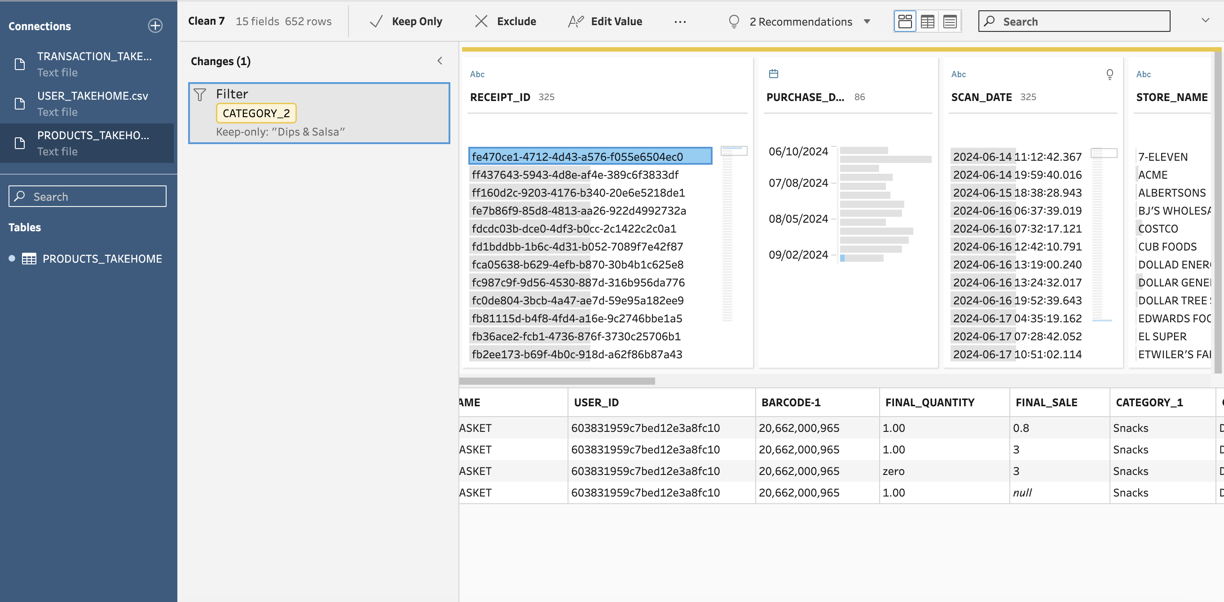

In the above scenario, this is the trend for all receipt_id , for the same barcode it shows different values for the both the fields Final quanity and Final sale . If distinct function is not used in the SQL statements this could lead to many errors .